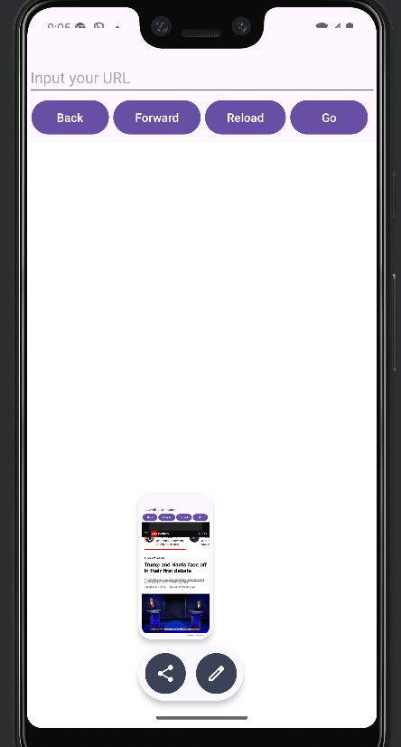 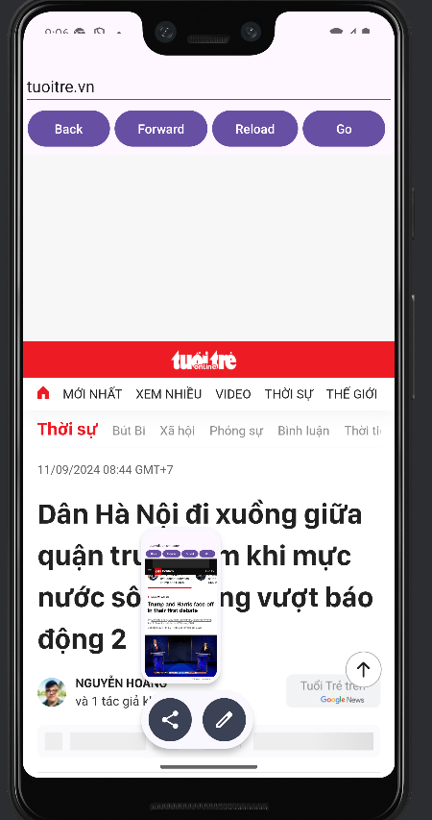

<?xml version="1.0" encoding="utf-8"?>  
<manifest xmlns:android="http://schemas.android.com/apk/res/android"  
 xmlns:tools="http://schemas.android.com/tools">  
  
 <uses-permission android:name="android.permission.INTERNET" />  
  
 <application  
 android:allowBackup="true"  
 android:dataExtractionRules="@xml/data_extraction_rules"  
 android:fullBackupContent="@xml/backup_rules"  
 android:icon="@mipmap/ic_launcher"  
 android:label="@string/app_name"

android:usesCleartextTraffic="true"

android:roundIcon="@mipmap/ic_launcher_round"  
 android:supportsRtl="true"  
 android:theme="@style/Theme.WebApp"  
 tools:targetApi="31">  
 <activity  
 android:name=".MainActivity"  
 android:exported="true">  
 <intent-filter>  
 <action android:name="android.intent.action.MAIN" />  
  
 <category android:name="android.intent.category.LAUNCHER" />  
 </intent-filter>  
 </activity>  
 </application>  
  
</manifest>

activity_main.xml

<?xml version="1.0" encoding="utf-8"?>  
<LinearLayout xmlns:android="http://schemas.android.com/apk/res/android"  
 xmlns:app="http://schemas.android.com/apk/res-auto"  
 xmlns:tools="http://schemas.android.com/tools"  
 android:id="@+id/main"  
 android:layout_width="match_parent"  
 android:layout_height="match_parent"  
 android:orientation="vertical"  
 android:layout_marginTop="50dp"  
 tools:context=".MainActivity">  
  
 <EditText  
 android:id="@+id/editText"  
 android:layout_width="match_parent"  
 android:layout_height="wrap_content"  
 android:layout_marginTop="10dp"  
 android:ems="10"  
 android:inputType="text"  
 android:hint="Input your URL"  
 />  
  
  
 <LinearLayout  
 android:layout_width="match_parent"  
 android:layout_height="wrap_content"  
 android:layout_marginHorizontal="5dp"  
  
 android:orientation="horizontal">  
  
 <Button  
 android:id="@+id/button"  
 android:layout_width="wrap_content"  
 android:layout_height="wrap_content"  
 android:layout_weight="1"  
 android:onClick="backButton"  
 android:layout_marginEnd="5dp"  
 android:text="Back" />  
  
 <Button  
 android:id="@+id/button2"  
 android:layout_width="wrap_content"  
 android:layout_height="wrap_content"  
 android:layout_marginEnd="5dp"  
 android:layout_weight="1"  
 android:onClick="fwdButton"  
 android:text="Forward" />  
  
 <Button  
 android:id="@+id/button3"  
 android:layout_width="wrap_content"  
 android:layout_height="wrap_content"  
 android:layout_weight="1"  
 android:onClick="reloadButton"  
 android:layout_marginEnd="5dp"  
 android:text="Reload" />  
  
 <Button  
 android:id="@+id/button4"  
 android:layout_width="wrap_content"  
 android:layout_height="wrap_content"  
 android:layout_weight="1"  
 android:layout_marginEnd="5dp"  
 android:onClick="goBack"  
 android:text="Go" />  
 </LinearLayout>  
  
 <WebView  
 android:layout_width="match_parent"  
 android:layout_height="match_parent"  
 android:layout_marginTop="5dp"  
 android:id="@+id/webView"  
 >  
  
  
 </WebView>  
  
</LinearLayout>

ActivityMain.java

